**Practical no-1 Roll no-59**

package example1.ws;

import javax.jws.WebService;

import javax.jws.WebMethod;

import javax.jws.WebParam;

/**

*

* @author USER

*/

@WebService(serviceName = "temperatureWS")

public class temperatureWS {

/**

* This is a sample web service operation

*/

@WebMethod(operationName = "hello")

public String hello(@WebParam(name = "name") String txt) {

return "Hello " + txt + " !";

}

/**

* Web service operation

*/

@WebMethod(operationName = "CelToFah")

public double CelToFah(@WebParam(name = "cel") double cel) {

//TODO write your implementation code here:

return (cel*9/5) + 32;

}

/**

* Web service operation

*/

@WebMethod(operationName = "FahToCel")

public String FahToCel(@WebParam(name = "fah") int fah) {

//TODO write your implementation code here:

int b=(fah-32)*5/9;

return "celsius is = "+ b;

}

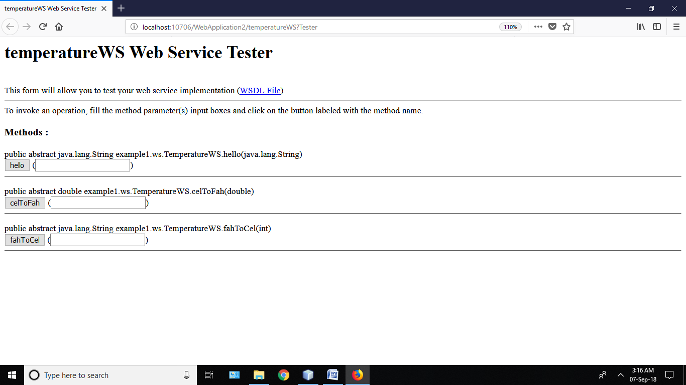

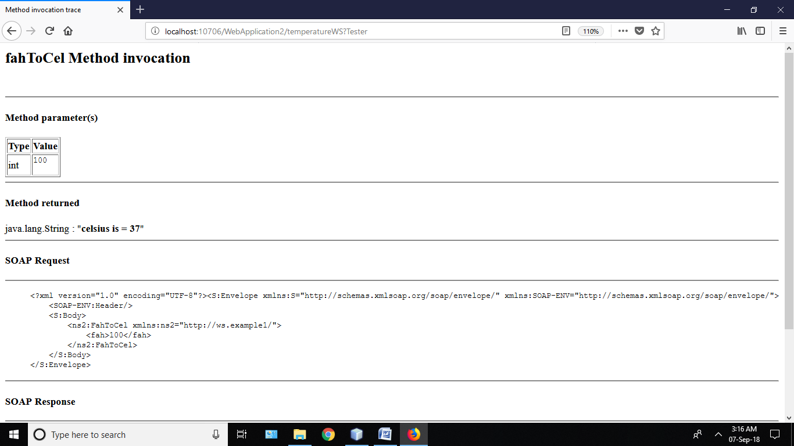

**Practical no -2 Roll no-59**

package oneway;

import javax.jws.Oneway;

import javax.jws.WebService;

import javax.jws.WebMethod;

import javax.jws.WebParam;

/**

*

* @author USER

*/

@WebService(serviceName = "NewWebService")

public class NewWebService {

String feedback,s;

/**

* This is a sample web service operation

*/

@WebMethod(operationName = "hello")

public String hello(@WebParam(name = "name") String txt) {

return "Hello " + txt + " !";

}

/**

* Web service operation

*/

@WebMethod(operationName = "ping")

@Oneway

public void ping() {

//TODO write your implementation code here:

System.out.println("ping");

feedback = "ok";

}

@WebMethod(operationName = "startApp")

public String startApp() {

//TODO write your implementation code here:

ping();

if(feedback =="ok"){

s = "Started";

}

else {

s = "not Started";

}

return s; } }

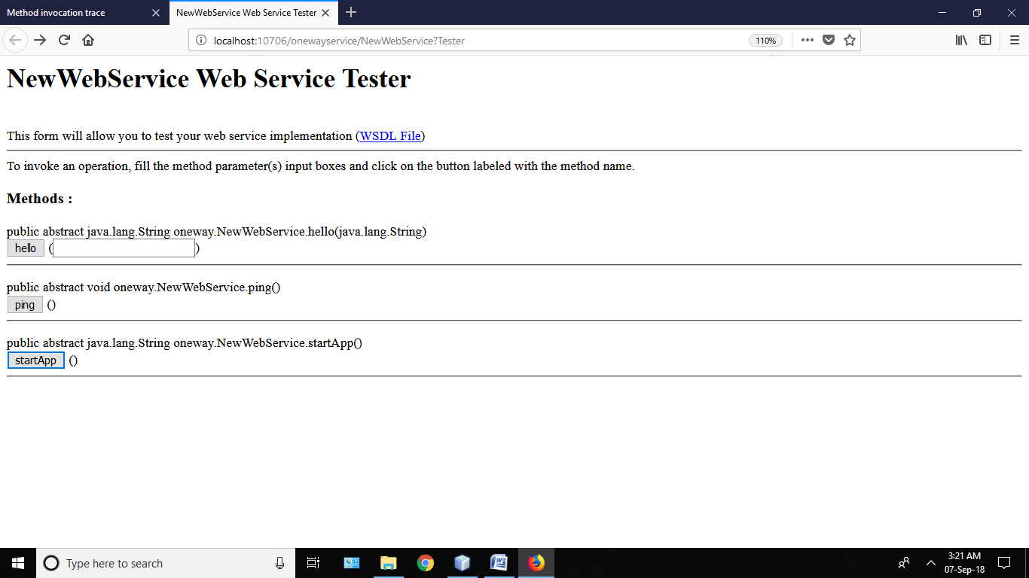

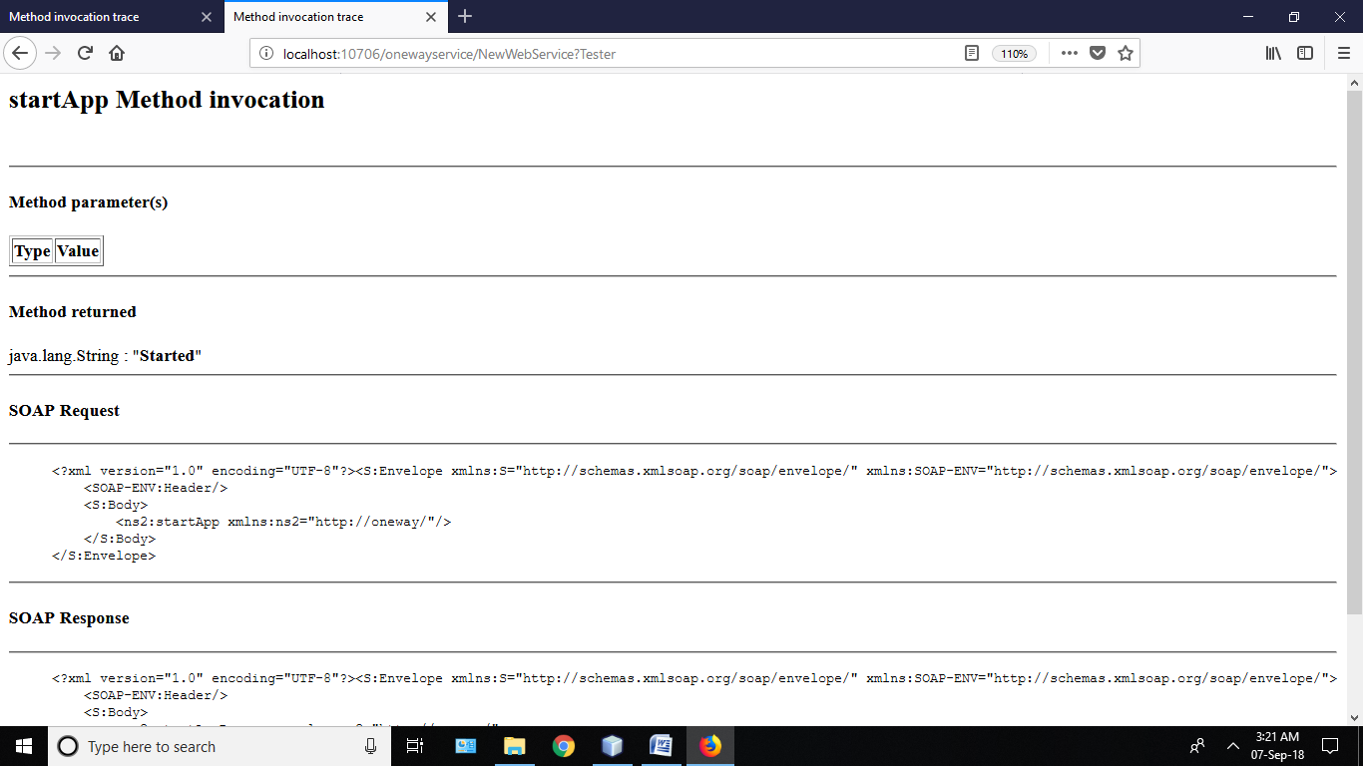

**Practical no – 3 Roll no - 59**

**EVENODD.java**

package numbers;

import javax.jws.WebService;

import javax.jws.WebMethod;

import javax.jws.WebParam;

/**

*

* @author USER

*/

@WebService(serviceName = "evenodd")

public class evenodd {

/**

* This is a sample web service operation

*/

@WebMethod(operationName = "hello")

public String hello(@WebParam(name = "name") String txt) {

return "Hello " + txt + " !";

}

/**

* Web service operation

*/

@WebMethod(operationName = "evenodd")

public String evenodd(@WebParam(name = "num1") int num1) {

//TODO write your implementation code here:

if(num1 % 2==0){

return "EVEN NUMBER";}

return null;

}

@WebMethod(operationName = "odd")

public String odd(@WebParam(name = "num1") int num1) {

//TODO write your implementation code here:

if(num1 % 2!=0){

return "ODD NUMBER";}

return null;

}

}

**EVENODDCLIENT.jsp**

<%@page contentType="text/html" pageEncoding="UTF-8"%>

<!DOCTYPE html>

<html>

<head>

<meta http-equiv="Content-Type" content="text/html; charset=UTF-8">

<title>JSP Page</title>

</head>

<body>

<h1>Hello World!</h1>

</body> <%-- start web service invocation --%><hr/>

<%

try {

evenodd.Evenodd_Service service = new evenodd.Evenodd_Service();

evenodd.Evenodd port = service.getEvenoddPort();

// TODO initialize WS operation arguments here

int num1 = 2;

// TODO process result here

java.lang.String result = port.evenodd(num1);

out.println("Result = "+result);

} catch (Exception ex) {

// TODO handle custom exceptions here

}

%>

<%-- end web service invocation --%><hr/>

</html>

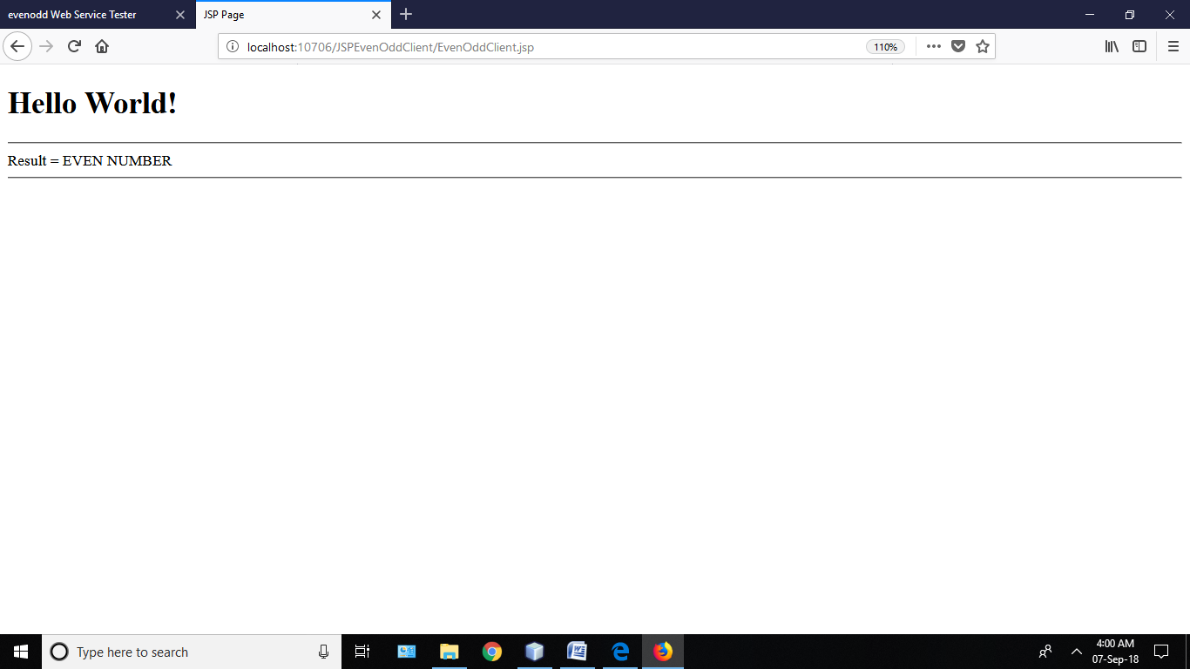

**Practical no -4 Roll no-59**

package employee;

import javax.jws.WebService;

import javax.jws.WebMethod;

import javax.jws.WebParam;

import org.json.simple.JSONObject;

/**

*

* @author USER

*/

@WebService(serviceName = "EmployeeWS")

public class EmployeeWS {

/**

* This is a sample web service operation

*/

@WebMethod(operationName = "hello")

public String hello(@WebParam(name = "name") String txt) {

return "Hello " + txt + " !";

}

/**

* Web service operation

*/

@WebMethod(operationName = "employee")

public String employee(@WebParam(name = "eid") String eid, @WebParam(name = "ename") String ename, @WebParam(name = "department") String department, @WebParam(name = "salary") String salary, @WebParam(name = "phone") String phone, @WebParam(name = "email") String email) {

JSONObject obj=new JSONObject();

obj.put("Id", eid);

obj.put("Name", ename);

obj.put("Department",department);

obj.put("Salary", salary);

JSONObject cont=new JSONObject();

cont.put("Phone", phone);

cont.put("Email", email);

obj.put("Contact",cont);

String s=obj.toString();

return s;

}

}

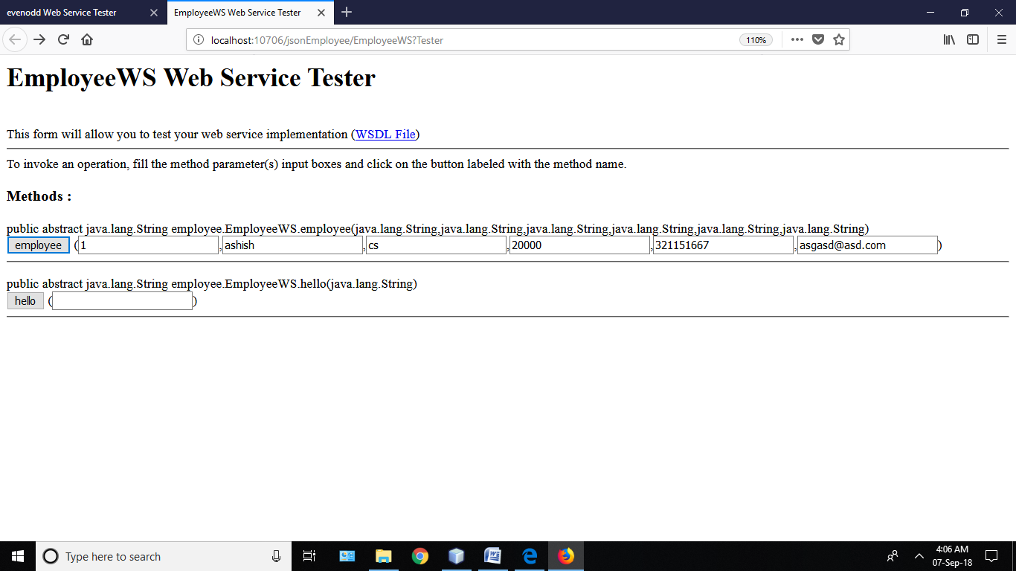

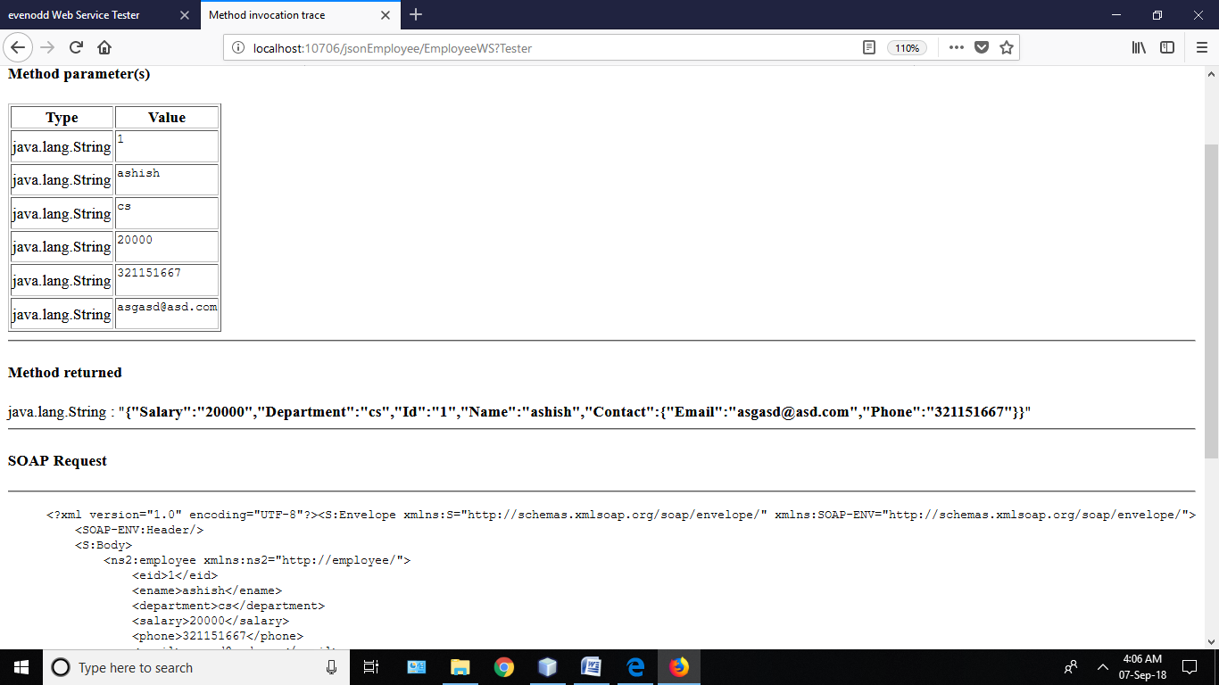

**Practical no – 5 Roll no-59**

**EvenOdd.java**

package numbers;

import javax.jws.WebService;

import javax.jws.WebMethod;

import javax.jws.WebParam;

/**

*

* @author USER

*/

@WebService(serviceName = "evenodd")

public class evenodd {

/**

* This is a sample web service operation

*/

@WebMethod(operationName = "hello")

public String hello(@WebParam(name = "name") String txt) {

return "Hello " + txt + " !";

}

/**

* Web service operation

*/

@WebMethod(operationName = "evenodd")

public String evenodd(@WebParam(name = "num1") int num1) {

//TODO write your implementation code here:

if(num1 % 2==0){

return "EVEN NUMBER";}

return null;

}

@WebMethod(operationName = "odd")

public String odd(@WebParam(name = "num1") int num1) {

//TODO write your implementation code here:

if(num1 % 2!=0){

return "ODD NUMBER";}

return null;

}

}

**Webform1.aspx.cs**

using System;

using System.Collections.Generic;

using System.Linq;

using System.Web;

using System.Web.UI;

using System.Web.UI.WebControls;

namespace EvenoddWebnetClient

{

public partial class WebForm1 : System.Web.UI.Page

{

protected void Page_Load(object sender, EventArgs e)

{

}

protected void Button1_Click(object sender, EventArgs e)

{

EvenOddnetclient.evenodd obj = new EvenOddnetclient.evenodd();

int a = Convert.ToInt32(TextBox1.Text);

Label1.Text=obj.Callevenodd(a);

}

}

}

